Name __________________________ Core _______ Date ____________________
Cumulative Check In 1.5
Complete each problem. Explain or show your reasoning! Work MUST be shown to receive any credit! Circle your final answer or input your answer into the grid if provided. All answers in the grid must be as decimals or proper or improper fractions (No mixed numbers).

Calculator Inactive (No Calculator)
1) Simplify: 3$\frac{1}{8}$ + 1$\frac{5}{6}$  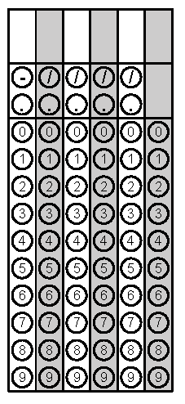 | 2) Simplify: 1$\frac{5}{9}$ x 2$\frac{1}{10}$
2) Simplify: 3$\frac{1}{8}$ - 1$\frac{5}{6}$ | 4) Find the area of the shaded region:  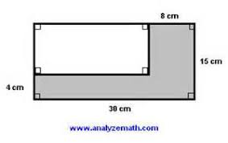
5) Find the area of the shape.  5 in  5 in  6 in  8 in  4 in | 6) Find the surface area of this shape:  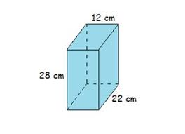
7) Find the volume of the shape: | 8) Find the area of this shape:  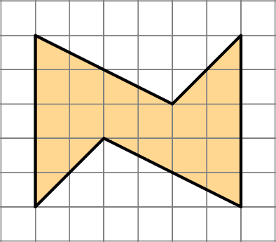
9) What is the side length of a square with an area of:  - 64 square inches  - 12² square inches  - 1 square centimeter | 10) What is the side length of a cube if the volume is:  - 64 cubic inches  - 13³ centimeters³  - 1 cubic centimeter

