Name __________________________ Core _______ Date ____________________
Cumulative Check In 6.1
Complete each problem. Explain or show your reasoning! Work MUST be shown to receive any credit! Circle your final answer or input your answer into the grid if provided. All answers in the grid must be as decimals or proper or improper fractions (No mixed numbers).
Calculator Inactive
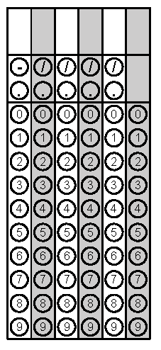  1) A motorcycle can go 40 miles using 3 gallons of gas. How many miles can it travel using 5 gallons of gas? | 2) One ounce of yogurt contains 1.2 grams of sugar. How many grams of sugar are in 14.25 ounces of yogurt?
3) Mai walked 1/8 of a 30-mile walking trail. How many miles did Mai walk? | 4) The mass of one coin is 16.718 grams. The mass of a second coin is 27.22 grams. How much greater is the mass of the second coin than the first?

5) Four students set up a lemonade stand. At the end of the day, their profit is $16.36. How much money do they each have when the profit is split equally? | 6) What is the volume of a prism that has a length of $1\frac{1}{2}$, a width of $2\frac{1}{4}$, and a height of $1\frac{1}{3}$?
7) Solve: ½m = 2¼ | 8) Find the value of the variable:  14 = m · $2\frac{1}{3}$
Calculator Active
9) Which of the polygons has the greatest area?  - A rectangle that is 3.25 inches wide and 6.1 inches long.  - A square with side length of 4.6 inches.  - A triangle with a base of 7.18 inches and a height of 5.4 inches. | 10) A sports drink bottle contains 16.9 fluid ounces. Andre drank 80% of the bottle. How many fluid ounces did Andre drink?

