Name __________________________ Core _______ Date ____________________
Cumulative Check In 5.2 Math 6 Plus
Complete each problem. Explain or show your reasoning! Circle your final answer or input your answer into the grid if provided. All answers in the grid must be as decimals or proper or improper fractions (No mixed numbers).
Calculator Inactive
1) Find the value of the variable:  $1\frac{1}{3}$∙ m = $4\frac{2}{5}$  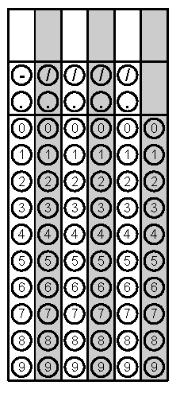 | 2) Max made 5 batches of Jello. He used 2 cups of sugar. How much sugar would he need for 1 batch?
3) Find the surface area of the pyramid below:  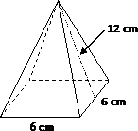 | 4) Ronald and Tim both did their laundry today. Ronald does laundry every 6 days and Tim does laundry every 9 days. How many days will it be until Ronald and Tim both do laundry on the same day again?

Calculator Inactive…still
5) Simplify: 7.7 ÷ 0.4 | 6) Find the area of the shaded region. All angles are right angles. Show your reasoning.  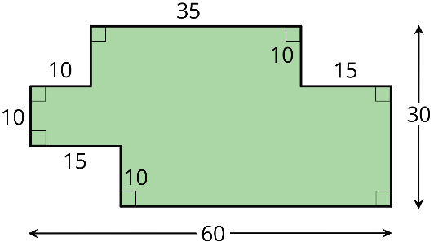
7) Diego bought 12 mini muffins for $4.20. At this rate, how much would Diego pay for 4 mini muffins? | 8) Which has a greater value: 7.4−0.0022 or 7.39−0.0012? Show your reasoning.
9) A grocery store sells bags of apples in two different sizes.  - The 2-pound bags of apples cost $3.  - The 3 - pound bags of apples for $8.  Which Which apples cost less per pound? Explain or show your reasoning  . | 10) Simplify: 5 x 0.065

