Name __________________________ Core _______ Date ____________________
Cumulative Check In 5.1 – Math 6
Complete each problem. Explain or show your reasoning! Circle your final answer or input your answer into the grid if provided. All answers in the grid must be as decimals or proper or improper fractions (No mixed numbers).
Calculator Inactive
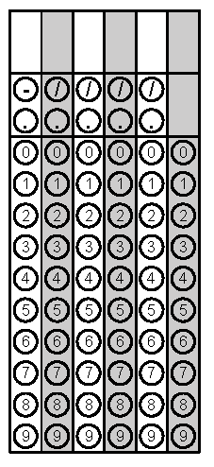  1) Solve: 3$\frac{5}{8}$ ÷ 5$\frac{1}{4}$ = | 2) Simplify: 7.4 x 0.19
3) If a cube has a volume of 27 cm³, then what is the measure of the edges of the cube? | 4) What is the area of the shape below: 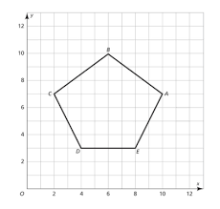
5) Find the surface area of the shape below: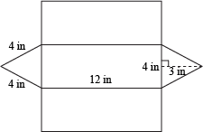 | 6) A kennel contains 250 cats and dogs. If there are 18 dogs for every 7 cats, then how many dogs are at the kennel?
Calculator Active
7) Which is the better by and by how much? $1.59 per pound of grapes or 5 pounds of grapes for $8. | 8) Kylie scored 22 free throws out of 40 attempts. What percent of the time did she miss the basket?
9) If 45% of a number, n, is 225, what is 74% of n? | 10) Sarah can read 15 pages in 36 minutes. How many minutes per page is that?

